webFLOW Configurator User Manual

History
Version | Date | Modification | Created by
0.1 | 17th Jan 2023 | Initial Draft | Tran Viet Thang (SX/BSV25-EA)

Contents
I. Overview 2
II. How To 2
1. The webFLOW Configurator fields: 2
o Delivery Type: 2
o Release Class 3
o Release Scope 3
o Limitations 3
o Limitation Description 4
o Safety Monitoring SW by RB 4
o Is Bosch responsible for data integration? 4
o Has Bosch responsibility for Safety Calibration? 4
o Has Bosch Cal Data Responsibility beside Safety Calibration? 4
o Functional limitations are mentioned in clear text in the release documentation 4
o Functional Safety is ensured in the non-limited area 4
2. How to Use webFLOW Configurator 4
III. Implementation Logic 5
IV. FAQ 5
3. Is Bosch Plant Introduction , End of Line Programming removed ? 5
4. Is the old job impacted or removed after webFLOW Configuration? 6
5. Is the Export and Import working? 6
6. If I have some comment or feedback , who should I contact for ? 6

Overview
WebFLOW Configurator is developed to resolve:
- Make the webFLOW job configuration more precisely in the beginning:
  - Move the configuration of job to the “Configuration Item” section in Request instance of the job.
  - Enhance the Tooltips of the field and its values to make clear
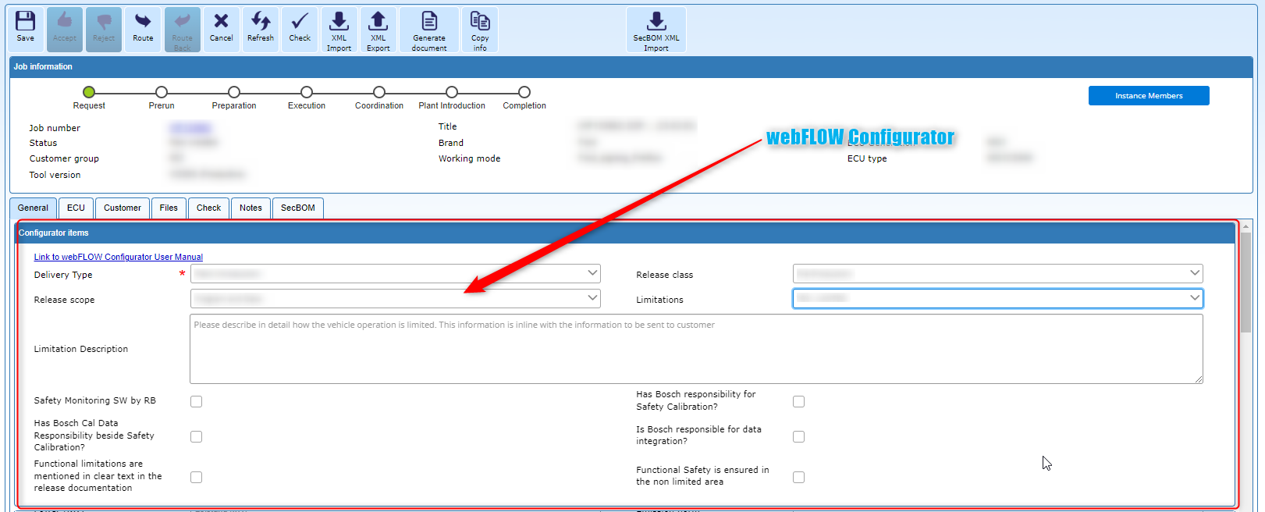
- Make the relationship between the release classes and artifacts clear. The validation (mandatory or not) will be based on the Implementation Logic section below
- SSD Compliance checking in Pre-Run Toolchain should be skipped in some use cases based on the Implementation Logic section below.

How To

The webFLOW Configurator fields:

Delivery Type:
The delivery type describes to whom we release. The selections decide about consequences, necessary actions.
Options | Description
Plant Introduction | The flash container will be forwarded to Bosch ECU plant
Customer EOL Flashing | The flash container will be forwarded to Customer for end of line flashing at vehicle plant
Plant + customer EOL | The flash container will be forwarded to Bosch, Bosch ECU and Customer vehicle plant

Release Class
The release class describes how the product can be used. The selections decide about consequences, necessary actions.
Options | Description
D-Muster | D-Sample Release, Initial Sample with test report for the customer as basis for release for series production delivery, not for end customer usage
Pilot | Similar like Pre-production, Pilot series to prove out production robustness, not for end customer usage
Pre-Production | To do production preparation in customer vehicle plant only; no end customer use intended and allowed
Production | Production, ready to use for end customer
Field Fix | A fix for an issue occurred in field, to update a previously delivered production release, ready to use for end customer
Customer service | A fix based on customer request, to update a previously delivered production release, ready to use for end customer
EWAK | To do production preparation in RB ECU plant only; no end customer use intended and allowed
Test | Only for testing, not allowed for production, production preparation or end customer use

Release Scope
The delivery type describes what do we release. The selections decide about consequences, necessary actions.
Options | Description
Data | Calibration data only will be released
Program and Data | Application SW and Calibration data will be released
Program | Application SW only will be released
Basis software | Base SW only will be released
Boot software | Boot SW only will be released

Limitations
Are there limitations to operate the vehicle applied, e.g. max speed limit, max engine revolution, limit, gear shift limit?
Options | Description
NO | This series release has no limitation, can be fully operated.
YES – LIMITED | This series release has limitations, to avoid full operation. This release is not allowed for end customer use, must be re-flashed in all cases.
YES - NO START | This series release has limitations, applied through no start configuration or calibration data. The SW cannot be operated and must be re-flashed in any case.

Limitation Description
Please describe in detail how limitations of vehicle operation has to be applied. This information is in-line with the information to be sent to customer.

Safety Monitoring SW by RB
Safety Monitoring SW by RB

Is Bosch responsible for data integration?
Is Bosch responsible for calibration data integration, means merging all calibration to one data set? The selections decides about consequences, necessary actions, e.g. data assessment of final system test.

Has Bosch responsibility for Safety Calibration?
This field is used to identify whether Bosch is responsible for safety monitoring calibration? The selections decide about consequences, necessary actions, e.g. ECU-MST.

Has Bosch Cal Data Responsibility beside Safety Calibration?
This field is used to identify whether Bosch is responsible for any calibration beside safety monitoring calibration? The selections decide about consequences, necessary actions.

Functional limitations are mentioned in clear text in the release documentation
The way to limit the operation of the vehicle or system is described in release notes towards customer. Activating this check box confirms this.

Functional Safety is ensured in the non-limited area
Functional Safety requirements are met in the non-limited area, confirmed by safety monitoring team. Activating this check box confirms this.

How to Use webFLOW Configurator
The feature WFC is impacting all the jobs which created after the feature released date only. After WFC releasing, the Request Instance of the jobs after created link image below:
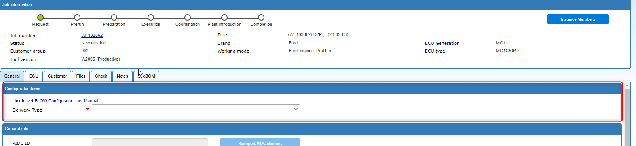
There is a new section called Configurator Items in the General Tabs. In this section the webFLOW configurator Input fields will be showed. There is the link on the top to this document.
At beginning, there is only new field called Delivery Type. Based on the job specification and the field description above, the necessaries options should be chosen. Refer the Implementation Logic section for more detail of the use cases. If your use case is not included here
Firstly, choose the Delivery Type, depend on your selection the Release Class and Release Scope will be showed.
Then you choose the Release Class and Release Scope. The Limitation field will be shown if neither EWAK, Test Version, Boot SW or Basis SW are chosen. The options of Limitation dropdown will be showed accordingly to Release Scope as well:
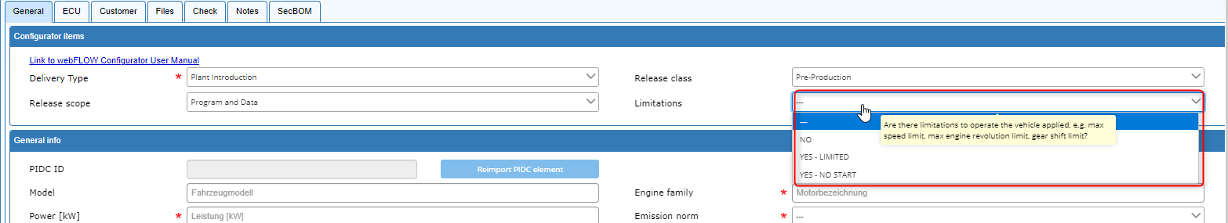

Then you select Limitation. Based on the Limitation value, the related checkboxes will be showed only (as the image below)
Then complete your job configuration by checking the checkboxes according to your job specification.

Implementation Logic
Refer the link : https://sites.inside-share3.bosch.com/sites/152352/Documents/30_SW/PDT/Intranet/Training/WFC_MasterTable_CAL_Check_Matrix.xlsx?d=w3dc2bdca1f4e48ef954796683731ce0b

FAQ

Are Bosch Plant Introduction , End of Line Programming and Creation of Container for RB Plant required? removed ?
=> No. They Preset the Field value and disable it based on Delivery Type Option: General Understanding is
  - If Delivery type = Plant , (BPI = Yes , EOL = No and Creation of RB Plant required? =Yes)

  - If Delivery type = Plant + EOL selected , (BPI = Yes , EOL = Yes and Creation of RB Plant required? =Yes)

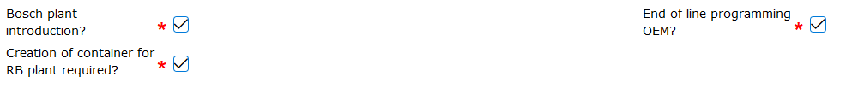
  - If Delivery type = EOL selected , (BPI = No . EOL = Yes ). The field Creation of RB Plant required? Will be available and editable.

Is the old job impacted or removed after webFLOW Configuration?
=> No. There should be no impact on the old jobs. They should be remained the same.

Is the Export and Import working?
=> Yes. The export and import features should be working.

If I have some comment or feedback , who should I contact for ?
=> If you have comment/feedback , please send it to our hotline : Tool-Hotline webFLOW and Product Delivery

